ICTCS 1320: Optimizing OSPFv2
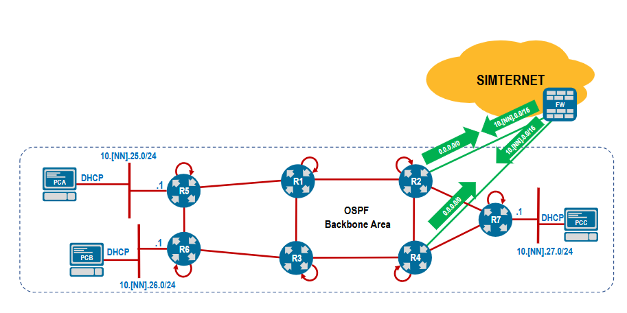

ping 10.46.27.100

router ospf 1
no passive-interface Ethernet 2
passive-interface default

interface Ethernet 1
ip ospf cost 65535

interface Ethernet 2
ip ospf authentication message-digest
ip ospf message-digest-key 1 sha512 lab123!

interface Ethernet 2
ip ospf network point-to-point

interface Ethernet1
ip address unnumbered Loopback0
default ip ospf cost
!

interface Ethernet2
ip address unnumbered Loopback0
default ip ospf cost
!

interface Ethernet3
ip address unnumbered Loopback0
default ip ospf cost
!

